Chapter 2, Problem 24.

For the circuit in Fig. 2.88, find V_{o} / V_{s} in terms of α, R₁, R₂, R₃, and R₄. If R₁ = R₂ = R₃ = R₄, what value of α will produce | V_{o} / V_{s} | = 10?

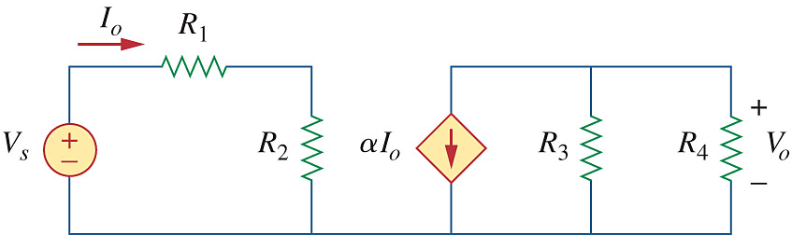

Figure 2.88
For Prob. 2.24

